Document Based Lesson:
Christopher Columbus
Central Historical Question: What motivated the brutality that Columbus and his soldiers inflicted on the Taíno people?

RESOURCE: Supplemental Timeline of Spanish Historical Context
- 711 CE- Armies of the Umayyad Caliphate invade Spain, beginning centuries of occupation by muslim Moors.
- 1453 CE- Constantinople, capital of the Holy Roman Empire and commercial gateway to the east falls to the Muslim Ottoman Empire.
- 1460 CE- To bypass powerful muslim empires in North Africa and Eastern Europe, Portugal establishes a colony in Guinea (West Africa) to trade for gold and slaves.
- 1478 CE- Castille (in Spain) attempts to capture the Portuguese colony in Guinea, but fails.
- 1479 CE- The Spanish Crown establishes the Spanish Inquisition, an organization meant to establish uniform Catholicism across Spain through the conversion, expulsion, or execution of non-Catholics, primarily targeting Jews and Muslims.
- 1481 CE- The Inquisition burns 6 accused heretics alive.
- 1488 CE- After 3 years of lobbying the King of Portugal to finance his journey, Christopher Columbus’s plan for an expedition seeking a westward route to China is denied. Columbus’s plan is also rejected by the English Crown, and the Republics of Genoa and Venice.
- 1492 CE- Moors surrender Granada, relinquishing the final Moorish stronghold in Europe, completing the reconquista.
- 1492 CE- The Inquisition orders the conversion or expulsion of all Jews from Spain.
- 1492 CE- The Spanish court of Ferdinand and Isabella agrees to finance Columbus’s westward expedition. Historians estimate Taino population of Hispaniola (present day Haiti and Dominican Republic) to be about 400,000.
- 1494 CE- Portugal disputes Spain’s claims to the West Indies. Pope Alexander VI brokers the Treaty of Tordesillas, dividing “newly discovered lands” between Portugal and Spain.
- 1495 CE- Due to famine, disease, and Spanish dominion, 50,000 Tainos die in 1495 alone.
- 1507 CE- Bartolome de las Casas reports that 60,000 Tainos remain on Hispaniola.
- 1531 CE- 600 Tainos remain on Hispaniola.

Document A: Description of Columbus’s Colonial Government MODIFIED

Endless testimonies... prove the mild and pacific temperament of the natives.... But our work was to exasperate, ravage, kill, mangle and destroy; small wonder, then, if they tried to kill one of us now and then.... The admiral, it is true, was blind as those who came after him, and he was so anxious to please the King that he committed irreparable crimes against the Indians....

[Spaniards] rode the backs of Indians if they were in a hurry [and] thought nothing of knifing Indians by tens and twenties and of cutting slices off them to test the sharpness of their blades. [Two] of these so-called Christians met two Indian boys one day, each carrying a parrot; they took the parrots and for fun beheaded the boys.

[The Tainos] ceased to procreate. As for the newly born, they died early because their mothers, overworked and famished, had no milk to nurse them, and for this reason, while I was in Cuba, 7000 children died in three months. Some mothers even drowned their babies from sheer desperation... In this way, husbands died in the mines, wives died at work, and children died from lack of milk ... and in a short time this land which was so great, so powerful and fertile ... was depopulated... My eyes have seen these acts so foreign to human nature, and now I tremble as I write...

[When I arrived on Hispaniola in 1508,] there were 60,000 people living on this island, including the Indians; so that from 1494 to 1508, over three million people had perished from war, slavery, and the mines. Who in future generations will believe this? I myself writing it as a knowledgeable eyewitness can hardly believe it…

Source: The History of the Indies (1561) by Bartolome de las Casas (1484-1566). De las Casas was a Dominican Priest who spent his life advocating for reform of the Spanish colonial system. The History of the Indies is the definitive firsthand account of the atrocities committed by the Spanish.

Document B: Excerpts from Columbus’s Journals MODIFIED
As soon as they see that they are safe and have laid aside all fear, they are very simple and honest and exceedingly generous with all they have… They exhibit great love toward all others in preference to themselves... I did not find, as some of us had expected, any cannibals among them, but, on the contrary, men of great deference and kindness… They brought us parrots and balls of cotton and spears and many other things, which they exchanged for the glass beads and hawks' bells. They willingly traded everything they owned... They were well-built, with good bodies and handsome features.... They do not bear arms, and do not know them, for I showed them a sword, they took it by the edge and cut themselves out of ignorance. They have no iron. Their spears are made of cane... They would make fine servants... With fifty men we could subjugate them all and make them do whatever we want. Let us in the name of the Holy Trinity go on sending all the slaves that can be sold.

Source: Excerpts from Columbus’s journal of his first voyage to San Salvador (present day Bahamas) (1492). Presented to Queen Isabella upon his return.

Document C: Excerpts from Columbus’s Report back to Queen Isabella of Spain MODIFIED
Hispaniola is a miracle. Mountains and hills, plains and pastures, are both fertile and beautiful... the harbors are unbelievably good and there are many wide rivers of which the majority contain gold... There are many spices, and great mines of gold and other metals... [I will bring the king and queen] as much gold as they need... and as many slaves as they ask… Thus the eternal God, our Lord, gives victory to those who follow His way over apparent impossibilities.

Source: From Columbus’s report back to King Ferdinand and Queen Isabella of Spain (1493). Upon his return, Columbus asked the crown for a fleet of ships and more men, ultimately receiving 17 ships and 1,200 men, with whom he returned to the Indies.

Document D: Excerpts from the Treaty of Tordesillas MODIFIED

. . . For the sake of peace and concord, and for the preservation of the relationship and love of the King of Portugal for the King and Queen of Spain, it being the pleasure of their Highnesses, they covenanted and agreed that a boundary or straight line be determined and drawn north and south, from pole to pole, on the said ocean sea, from the Arctic to the Antarctic pole. This boundary or line shall be drawn straight, as aforesaid, at a distance of three hundred and seventy leagues west of the Cape Verde Islands. And all lands, both islands and mainlands, found and discovered already, or to be found and discovered hereafter, by the said King of Portugal and by his vessels on the eastern side of the said line shall belong to and remain in the possession of, and pertain forever to, the said King of Portugal and his successors. And all other lands, both islands and mainlands, found or to be found hereafter by the said King and Queen of Spain and by their vessels, on the western side of the said line shall belong to the said King and Queen of Spain and to their successors.

And by this present agreement, they entreat our most Holy Father that his Holiness be pleased to confirm and approve this said agreement…

The Treaty of Tordesillas (1494) was written by Pope Alexander VI to resolve disputes between Portugal and Spain over “newly discovered lands.” Portugal and Spain were the two most important Catholic kingdoms in Europe at the time.

Document E: The Virgin of the Navigators
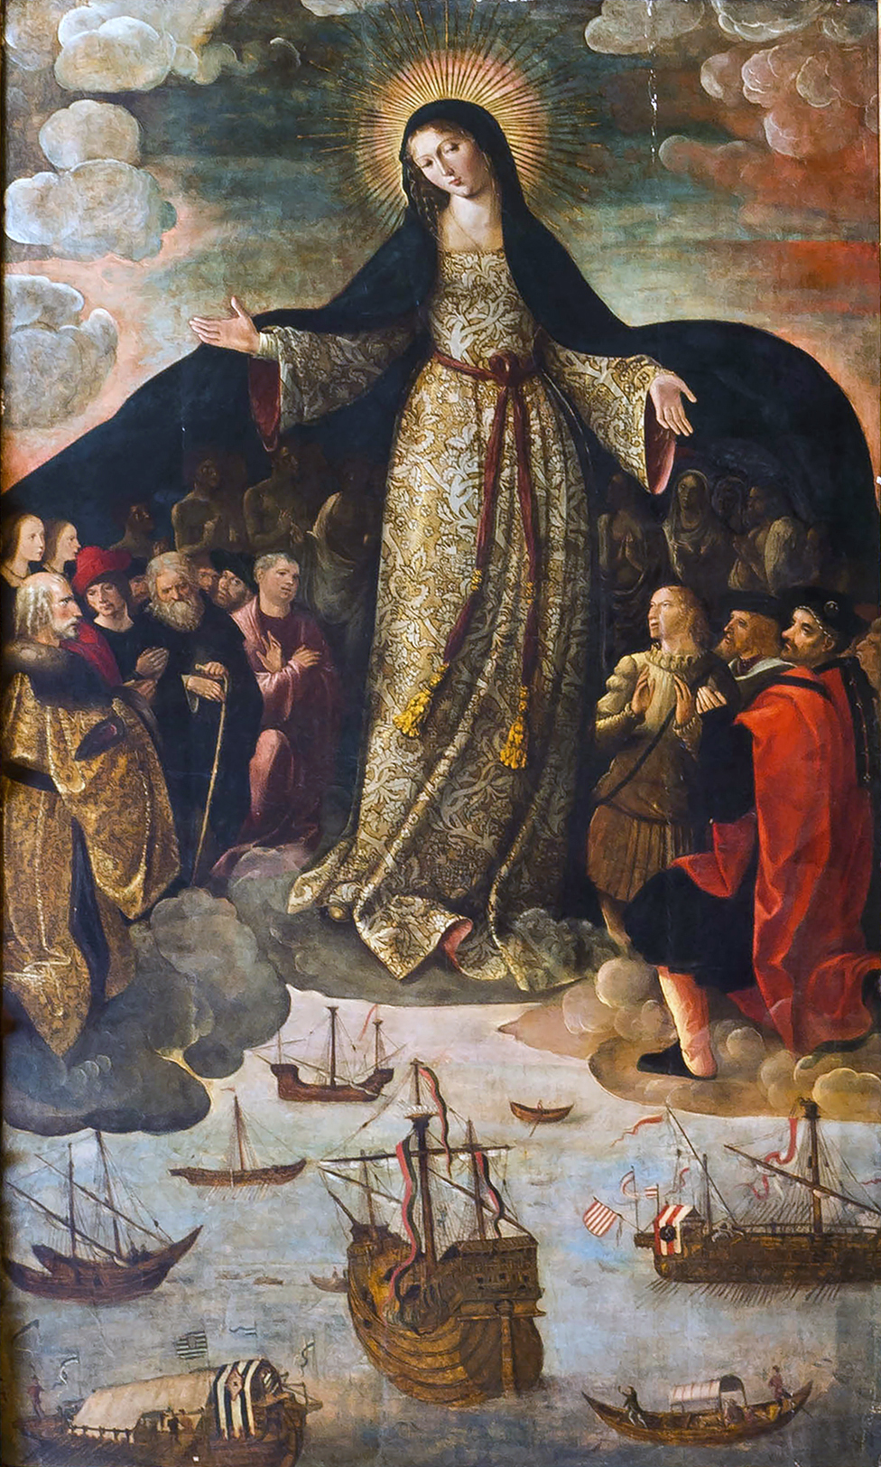
Source: 1536 altarpiece by Spanish painter Alejo Fernandez, commissioned for a church in Seville, Spain. It is the first painting depicting the discovery of the Americas. Famous navigators, including Columbus, are depicted kneeling before the Virgin Mary.

