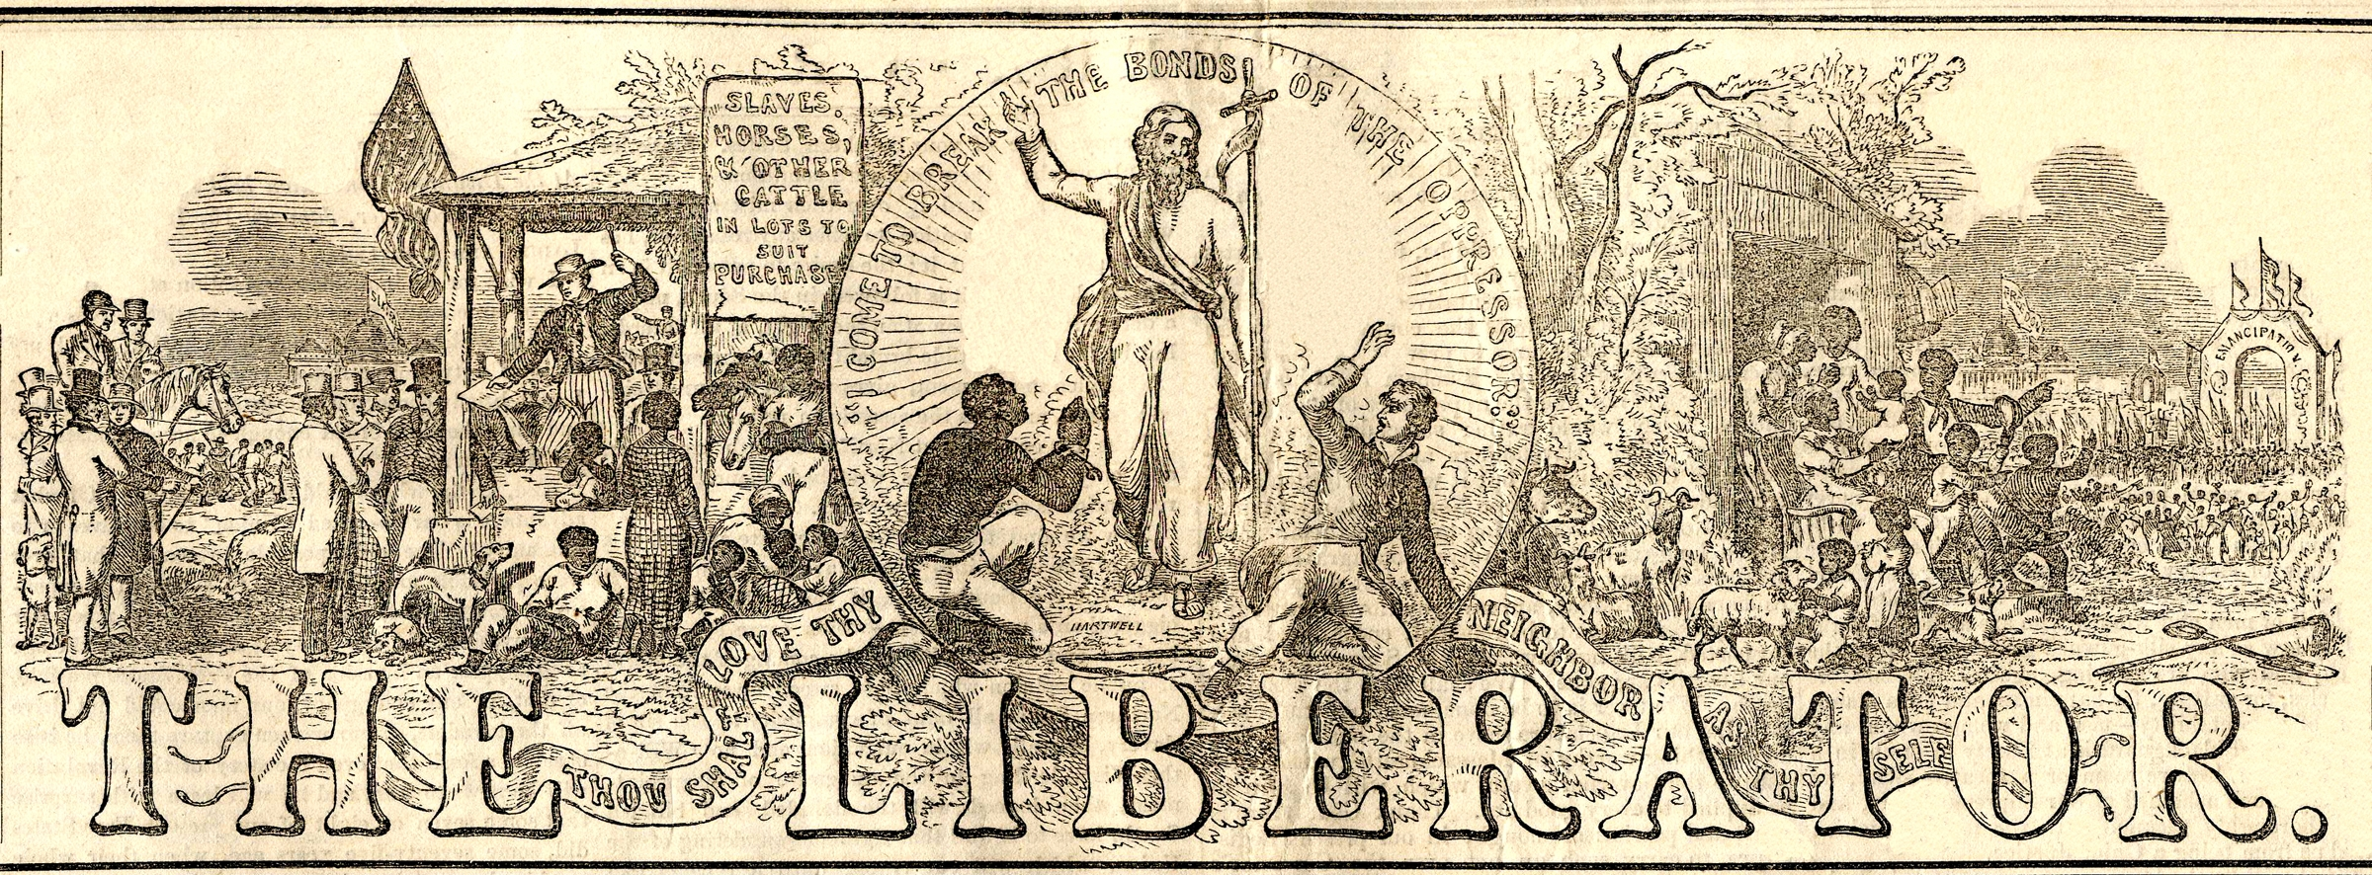
Excerpt from “The Great Crisis!” (1832)
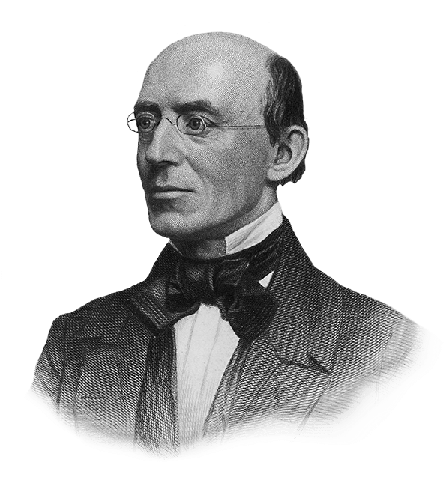
William Lloyd Garrison

William Lloyd Garrison (1805-1879) was a radical abolitionist, based in Massachusetts. His abolitionist newspaper, The Liberator, from which this excerpt is taken, was published weekly from 1831 until slavery was abolished by the 13th Amendment in 1865.
There is much declamation about the sacredness of the compact which was formed between the free and slave states, on the adoption of the Constitution. A sacred compact, forsooth! We pronounce it the most bloody and heaven-daring arrangement ever made by men for the continuance and protection of a system of the most atrocious villainy ever exhibited on earth. Yes—we recognize the compact, but with feelings of shame and indignation, and it will be held in everlasting infamy by the friends of justice and humanity throughout the world. It was a compact formed at the sacrifice of the bodies and souls of millions of our race, for the sake of achieving a political object—an unblushing and monstrous coalition to do evil that good might come. Such a compact was, in the nature of things and according to the law of God, null and void from the beginning. No body of men ever had the right to guarantee the holding of human beings in bondage. Who or what were the framers of our government, that they should dare confirm and authorise such high-handed villany—such flagrant robbery of the inalienable rights of man—such a glaring violation of all the precepts and injunctions of the gospel—such a savage war upon a sixth part of our whole population?—They were men, like ourselves—as fallible, as sinful, as weak, as ourselves. By the infamous bargain which they made between themselves, they virtually dethroned the Most High God, and trampled beneath their feet their own solemn and heaven-attested Declaration, that all men are created equal, and endowed by their Creator with certain inalienable rights—among which are life, liberty, and the pursuit of happiness. They had no lawful power to bind themselves, or their posterity, for one hour—for one moment—by such an unholy alliance. It was not valid then—it is not valid now. Still they persisted in maintaining it—and still do their successors, the people of Massachusetts, of New-England, and of the twelve free States, persist in maintaining it. A sacred compact! A sacred compact! What, then, is wicked and ignominious?
This, then, is the relation in which we of New-England stand to the holders of slaves at the south, and this is virtually our language toward them—Go on, most worthy associates, from day to day, from month to month, from year to year, from generation to generation, plundering two millions of human beings of their liberty and the fruits of their toil—driving them into the fields like cattle—starving and lacerating their bodies—selling the husband from his wife, the wife from her husband, and children from their parents—spilling their blood—withholding the bible from their hands and all knowledge from their minds—and kidnapping annually sixty thousand infants, the offspring of pollution and shame! Go on, in these practices—we do not wish nor mean to interfere, for the rescue of your victims, even by expostulation or warning—we like your company too well to offend you by denouncing your conduct—although we know that by every principle of law which does not utterly disgrace us by assimilating us to pirates, that they have as good and true a right to the equal protection of the law as we have; and although we ourselves stand prepared to die, rather than submit even to a fragment of the intolerable load of oppression to which we are subjecting them—yet, never mind—let that be—they have grown old in suffering and we iniquity—and we have nothing to do now but to speak peace, peace, to one another in our sins. We are too wicked ever to love them as God commands us to do—we are so resolute in our wickedness as not even to desire to do so—and we are so proud in our iniquity that we will hate and revile whoever disturbs us in it. We want, like the devils of old, to be let alone in our sin. We are unalterably determined, and neither God nor man shall move us from this resolution, that our colored fellow subjects never shall be free or happy in their native land. Go on, from bad to worse—add link to link to the chains upon the bodies of your victims—add constantly to the intolerable burdens under which they groan—and if, goaded to desperation by your cruelties; they should rise to assert their rights and redress their wrongs, fear nothing—we are pledged, by a sacred compact, to shoot them like dogs and rescue you from their vengeance! Go on—we never will forsake you, for there is honor among thieves—our swords are ready to leap from their scabbards, and our muskets to pour forth deadly volleys, as soon as you are in danger. We pledge you our physical strength, by the sacredness of the national compact—a compact by which we have enabled you already to plunder, persecute, and destroy two millions of slaves, who now lie beneath the sod; and by which we now give you the same piratical license to prey upon a much larger number of victims and all their posterity. Go on—and by this sacred instrument, the Constitution of the United States, dripping as it is with human blood, we solemnly pledge you our lives, our fortunes, and our sacred honor, that we will stand by you to the last.

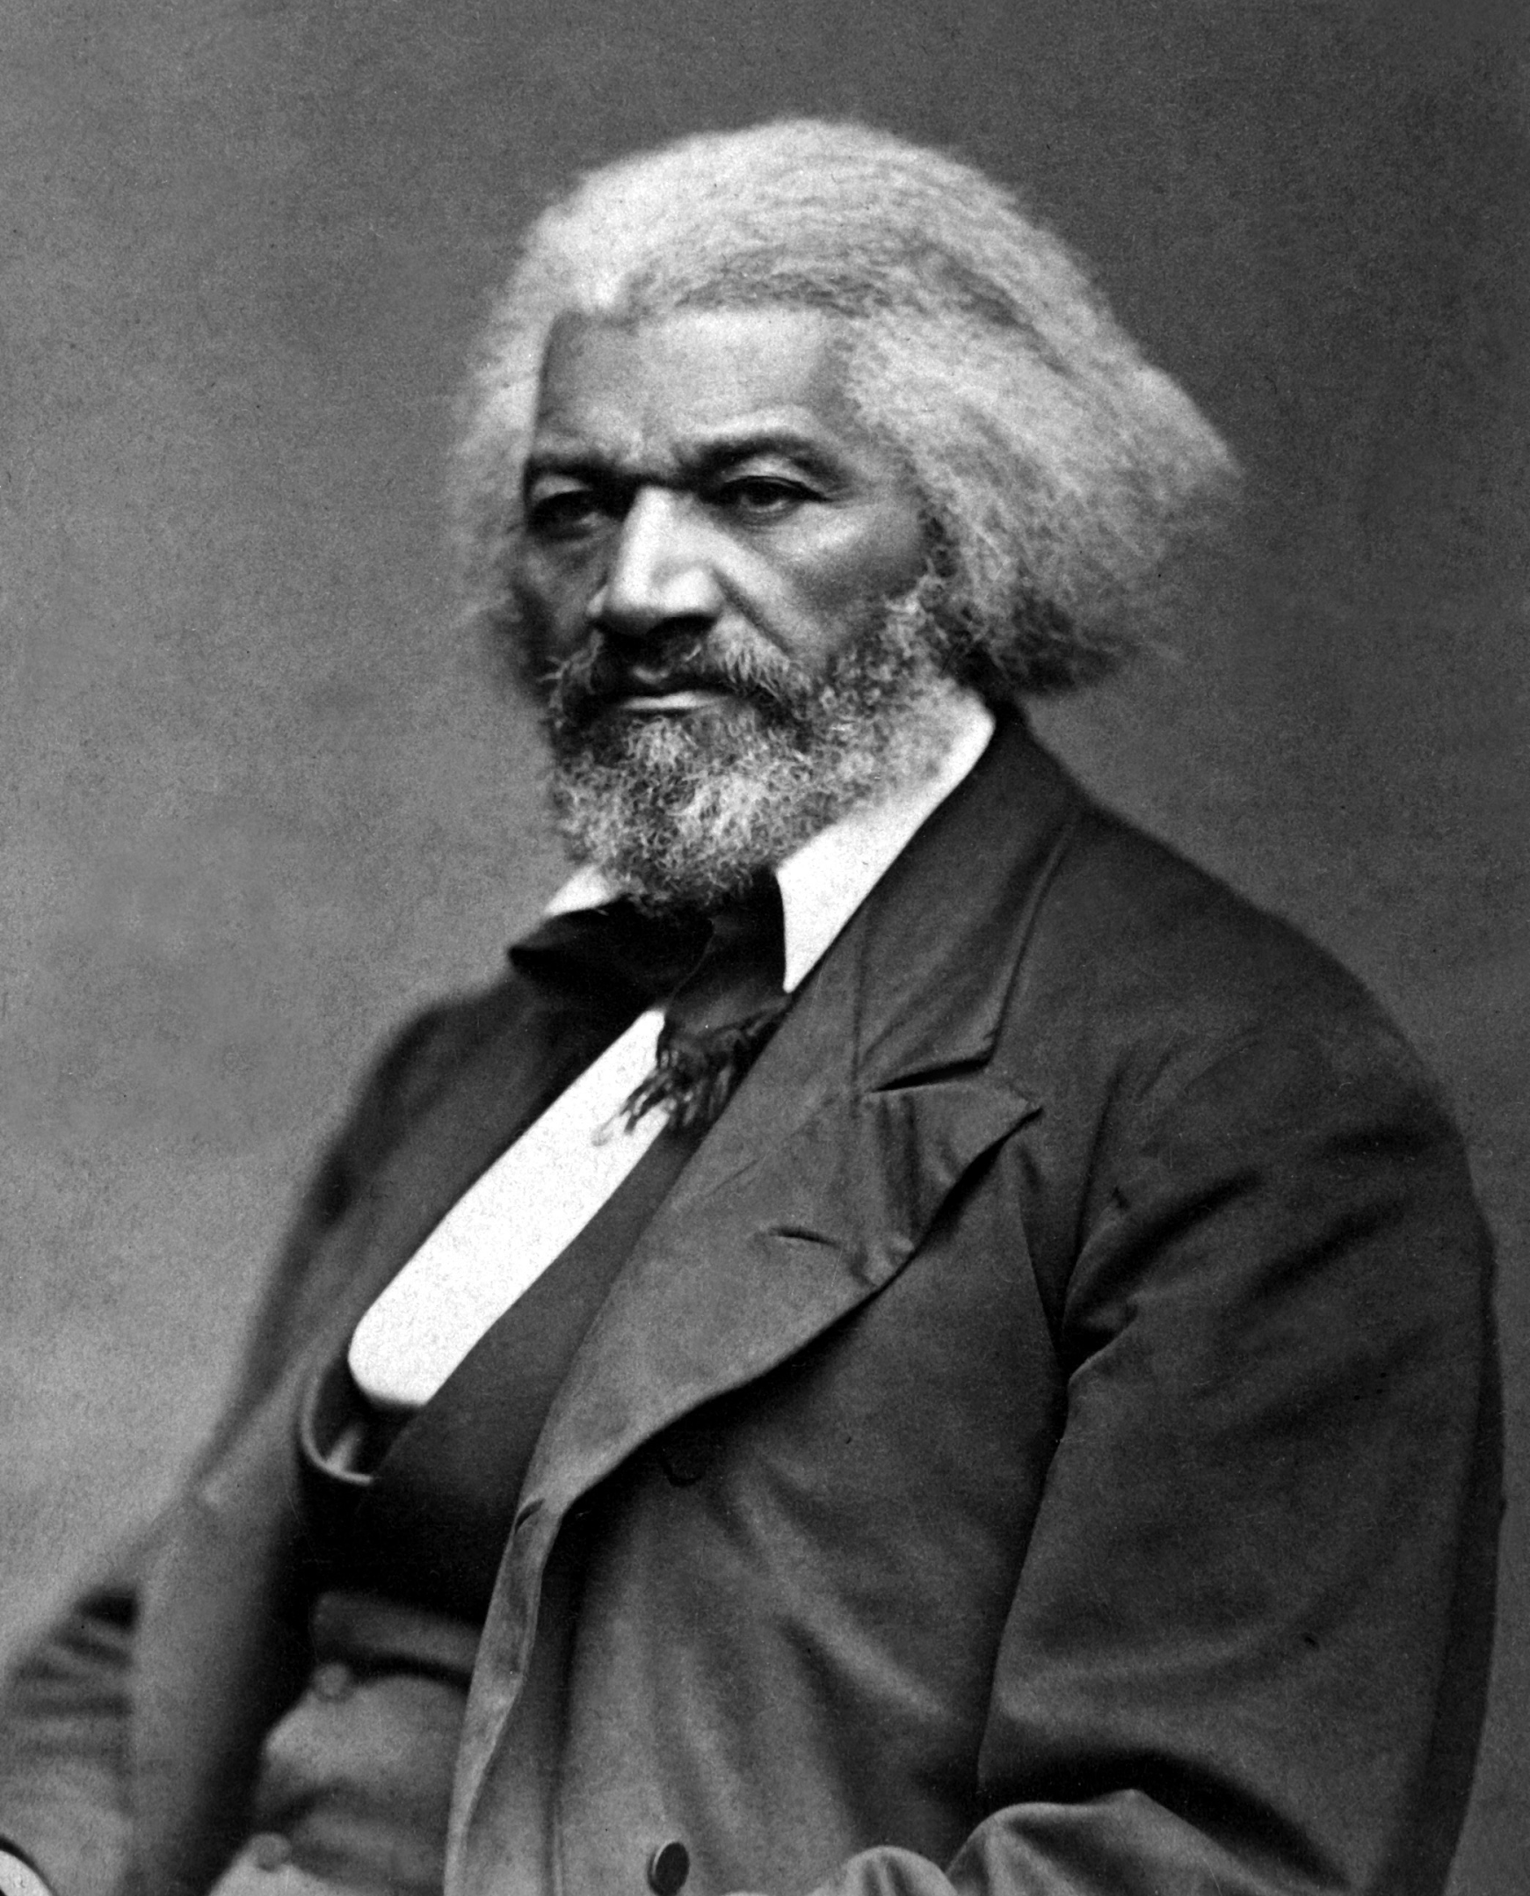
The Constitution of the United States:

Is It Pro-Slavery or Anti-Slavery?
March 26, 1860
Frederick Douglass (1818-1895)

Frederick Douglass was born into slavery, but escaped to freedom at age 20. He became a bestselling author, gave lectures around the world. Douglass was a lifelong activist for Emancipation and women’s suffrage, among other causes.
…The American Government and the American Constitution are spoken of in a manner which would naturally lead the hearer to believe that one is identical with the other; when the truth is, they are distinct in character as is a ship and a compass. The one may point right and the other steer wrong. A chart is one thing, the course of the vessel is another. The Constitution may be right, the Government is wrong. If the Government has been governed by mean, sordid, and wicked passions, it does not follow that the Constitution is mean, sordid, and wicked. What, then, is the question? I will state it. But first let me state what is not the question. It is not whether slavery existed in the United States at the time of the adoption of the Constitution; it is not whether slaveholders took part in the framing of the Constitution; it is not whether those slaveholders, in their hearts, intended to secure certain advantages in that instrument for slavery; it is not whether the American Government has been wielded during seventy-two years in favour of the propagation and permanence of slavery; it is not whether a pro-slavery interpretation has been put upon the Constitution by the American Courts — all these points may be true or they may be false, they may be accepted or they may be rejected, without in any wise affecting the real question in debate. The real and exact question between myself and the class of persons represented by the speech at the City Hall may be fairly stated thus: — 1st, Does the United States Constitution guarantee to any class or description of people in that country the right to enslave, or hold as property, any other class or description of people in that country? 2nd, Is the dissolution of the union between the slave and free States required by fidelity to the slaves, or by the just demands of conscience? Or, in other words, is the refusal to exercise the elective franchise, and to hold office in America, the surest, wisest, and best way to abolish slavery in America?
To these questions the Garrisonians say Yes. They hold the Constitution to be a slaveholding instrument, and will not cast a vote or hold office, and denounce all who vote or hold office, no matter how faithfully such persons labour to promote the abolition of slavery. I, on the other hand, deny that the Constitution guarantees the right to hold property in man, and believe that the way to abolish slavery in America is to vote such men into power as well use their powers for the abolition of slavery. This is the issue plainly stated, and you shall judge between us. Before we examine into the disposition, tendency, and character of the Constitution, I think we had better ascertain what the Constitution itself is… The American Constitution is a written instrument full and complete in itself. No Court in America, no Congress, no President, can add a single word thereto, or take a single word threreto. It is a great national enactment done by the people, and can only be altered, amended, or added to by the people… [It] should be borne in mind that the mere text, and only the text, and not any commentaries or creeds written by those who wished to give the text a meaning apart from its plain reading, was adopted as the Constitution of the United States. It should also be borne in mind that the intentions of those who framed the Constitution, be they good or bad, for slavery or against slavery, are so respected so far, and so far only, as we find those intentions plainly stated in the Constitution. It would be the wildest of absurdities, and lead to endless confusion and mischiefs, if, instead of looking to the written paper itself, for its meaning, it were attempted to make us search it out, in the secret motives, and dishonest intentions, of some of the men who took part in writing it. It was what they said that was adopted by the people, not what they were ashamed or afraid to say, and really omitted to say. Bear in mind, also, and the fact is an important one, that the framers of the Constitution sat with doors closed, and that this was done purposely, that nothing but the result of their labours should be seen, and that that result should be judged of by the people free from any of the bias shown in the debates. It should also be borne in mind, and the fact is still more important, that the debates in the convention that framed the Constitution, and by means of which a pro-slavery interpretation is now attempted to be forced upon that instrument, were not published till more than a quarter of a century after the presentation and the adoption of the Constitution…
[Slavery’s] hope of life, in the last resort, is to get out of the Union. I am, therefore, for drawing the bond of the Union more completely under the power of the Free States. What they most dread, that I most desire. I have much confidence in the instincts of the slaveholders. They see that the Constitution will afford slavery no protection when it shall cease to be administered by slaveholders. They see, moreover, that if there is once a will in the people of America to abolish slavery, this is no word, no syllable in the Constitution to forbid that result. They see that the Constitution has not saved slavery in Rhode Island, in Connecticut, in New York, or Pennsylvania…

Historical Debate: Is the US Constitution a Pro-Slavery or Anti-Slavery document?
Name: _________________________________ Pd: ________ Date: ___________________
William Lloyd Garrison
“The Great Crisis!” Debrief Questions
Respond to each of the following questions with a short paragraph, citing at least one quotation from the text.

- To Garrison, the Constitution is essentially a compact (or agreement) between which two groups? He then asserts that the Constitution is fundamentally invalid; what is his reasoning?

- What document does he consider superior to the Constitution? What is his reasoning?

- What is Garrison’s purpose in the long, final paragraph? Who is he mocking? How and why does he mock them?

- Based on this article, does Garrison consider the Constitution a Pro-Slavery or Anti-Slavery document? Explain your answer.

Historical Debate: Is the US Constitution a Pro-Slavery or Anti-Slavery document?
Frederick Douglass
“The Constitution of the United States…” Debrief Questions’
Respond to each of the following questions with a short paragraph, citing at least one quotation from the text.

- Explain the distinction Douglass makes between the US Government and the US Constitution. How does this affect the debate question above?

- At the bottom of the first page, Douglass explains the position of Garrison and his followers. What is their opinion on the debate question? What is their proposed solution to the existence of southern slavery?

- What is Douglass’s proposed solution to the existence of southern slavery?

- In the last paragraph, explain Douglass position on the Garrisonians desire to leave the union over slavery.

- Based on this article, does Douglass consider the Constitution a Pro-Slavery or Anti-Slavery document? Explain your answer.

The human race.
Alliance
Slavery
Capable of error
The Declaration of Independence
Shameful
In this paragraph, Garrison mocks the tolerance of slavery by the free states. The “we” refers to free states, the “you” refers to slaveholding states.
“They” here referring to enslaved people. Garrison criticizes the national government's violent suppression of slave uprisings
Here, Douglass is responding to William Lloyd Garrison’s position, that the moral duty of free states is to break off from slave states, and that anyone who holds office or votes in the United States is tacitly endorsing slavery.

